VeriFactAI Complete Program Flow
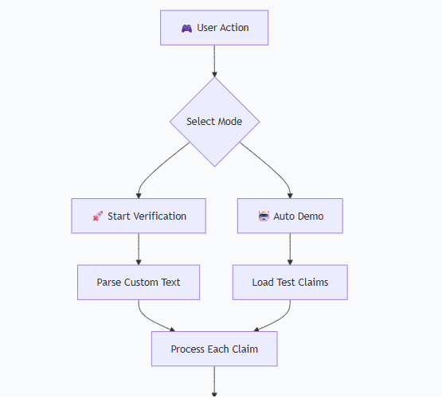
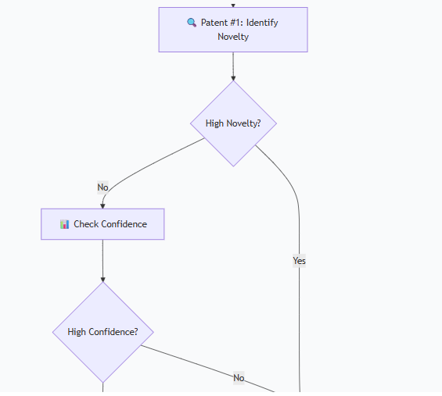
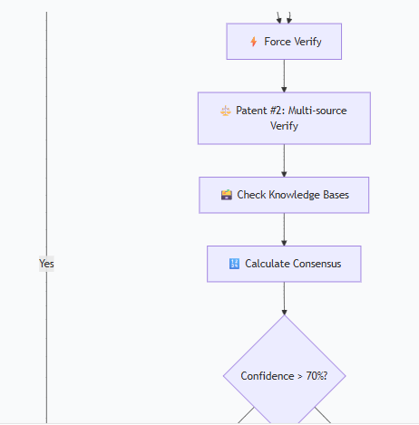
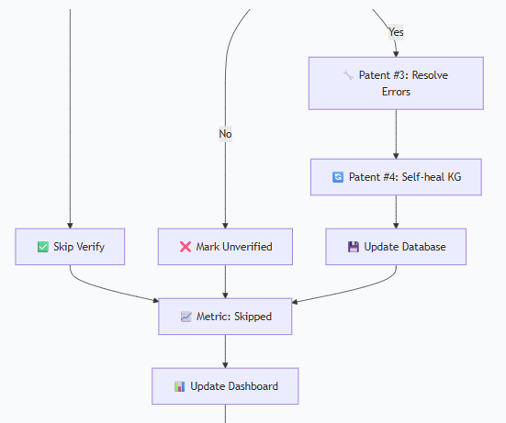


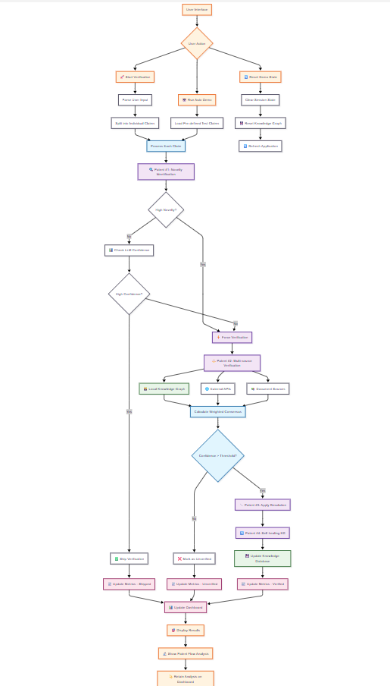

Detailed Component Flow

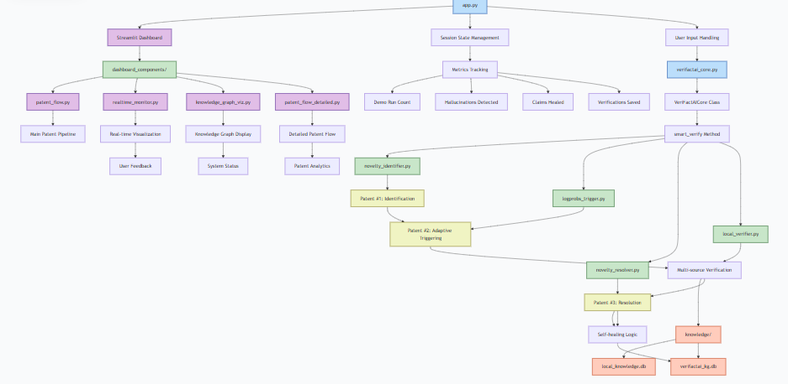

Patent Value Chain Flow

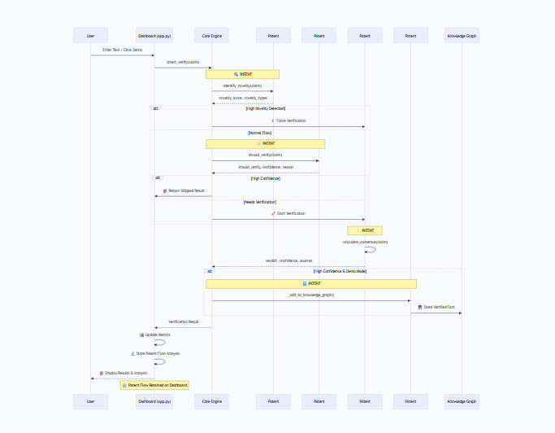

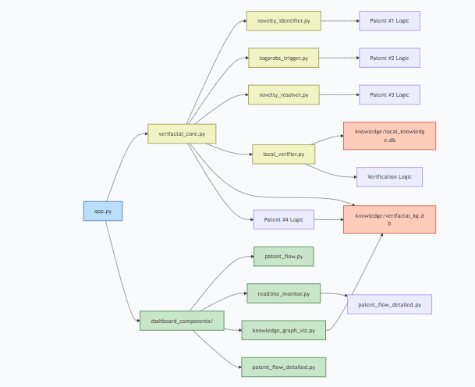

Key Flow Points:
- User Interaction → Dashboard handles input
- Core Engine → Orchestrates all patent logic
- Patent Chain → Sequential execution of 4 patents
- Data Persistence → Knowledge graph self-healing
- Visual Feedback → Real-time dashboard updates
- Analysis Retention → Patent flow stays visible
This flow demonstrates the complete value chain from user input to persistent knowledge improvement!

